Ramesh san
He presented his research plan. There has been some modifications.

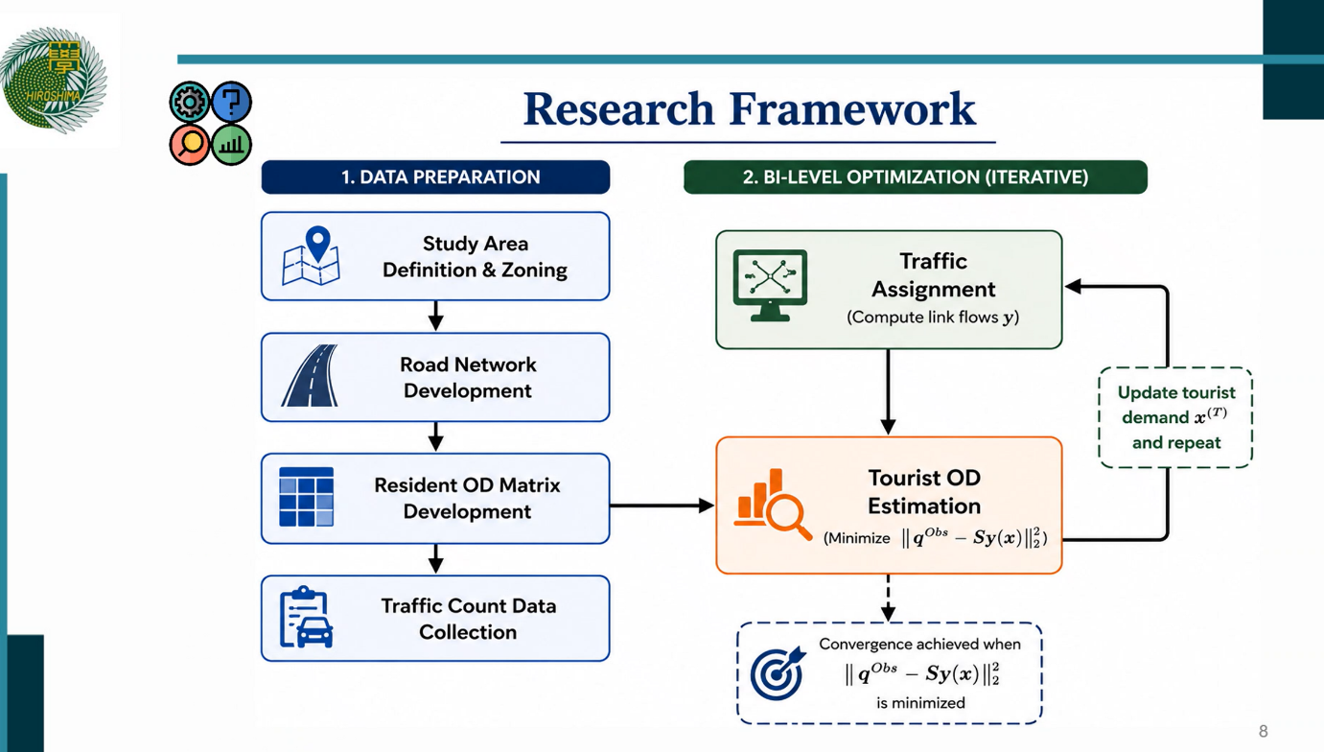

Resident OD matrix will be obtained from survey.
Existing link flow counts will be obtained from video survey
Tourist OD matrix will obtained from the difference of existing traffic flow minus the resident traffic flow.
It will done by convergence starting from assuming a non negative value, and convergence through iterations.
Azis san asked to make sure to understand attributes of the resident OD matrix, otherwise the simulation will lead to ambiguous analysis.
Azis san also recommended to add some tourism related data to highlight the significance of tourism in Nepal’s economy.
Azis san also recommended to include the significance of developing the inverse O-D matrix for tourist demand.
Kevin san:
explained what data will be required, how he can acquire those
Azis san explained the bike mode choice related issues (that I did not understand)
Azis san commented to include an explanation or justifications to analyze only the mode shift from Private cars to bi cycle.
What is the academic contribution of this research?
Why 3D- MFD approach is suitable for your research?
What is multi modal production?

